28. Diffie–Hellman Protocol
CODE:
#include <stdio.h>
long long powerMod(long long base, long long exp, long long mod) { long long result = 1;
while (exp > 0)
{
result = (result * base) % mod;
exp--;
}
return result;
}
int main() { long long q = 23; long long a = 5;
long long x = 6; // Alice's secret
long long y = 15; // Bob's secret
long long A = powerMod(a, x, q);
long long B = powerMod(a, y, q);
long long aliceKey = powerMod(B, x, q);
long long bobKey = powerMod(A, y, q);
printf("Public prime q = %lld\n", q);
printf("Public number a = %lld\n", a);
printf("Alice sends: %lld\n", A);
printf("Bob sends: %lld\n", B);
printf("Alice's key = %lld\n", aliceKey);
printf("Bob's key = %lld\n", bobKey);
if (aliceKey == bobKey)
printf("Shared key established successfully.\n");
printf("\nIf Alice and Bob send x*a and y*a instead,\n");
printf("Eve can observe these values and recover x and y\n");
printf("when a is known. Therefore it is insecure.\n");
return 0;
}
Output:
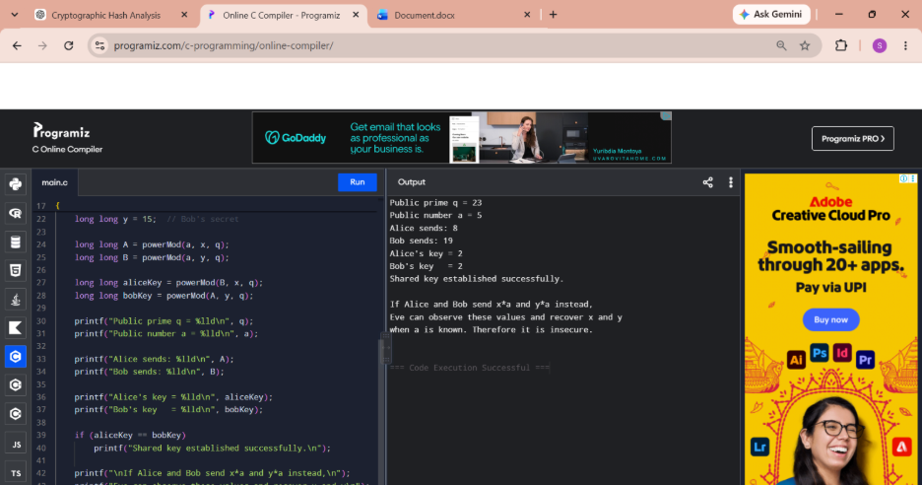
29 Diffie–Hellman Protocol
#include <stdio.h>

int main()
{
int totalBits = 1600;
int rateBits = 1024;
int laneBits = 64;

int capacityBits = totalBits - rateBits;
int capacityLanes = capacityBits / laneBits;

printf("SHA-3 State : %d bits\n", totalBits);
printf("Rate : %d bits\n", rateBits);
printf("Capacity : %d bits\n", capacityBits);
printf("Capacity lanes : %d\n", capacityLanes);

printf("\nInitial capacity lanes:\n");

for (int i = 0; i < capacityLanes; i++)
printf("Lane %d = 0\n", i);

printf("\nPermutation is ignored.\n");
printf("Only rate lanes are affected during absorption.\n");
printf("Therefore capacity lanes remain zero.\n");
printf("Time required for all capacity lanes to become nonzero: NEVER.\n");

return 0;
}
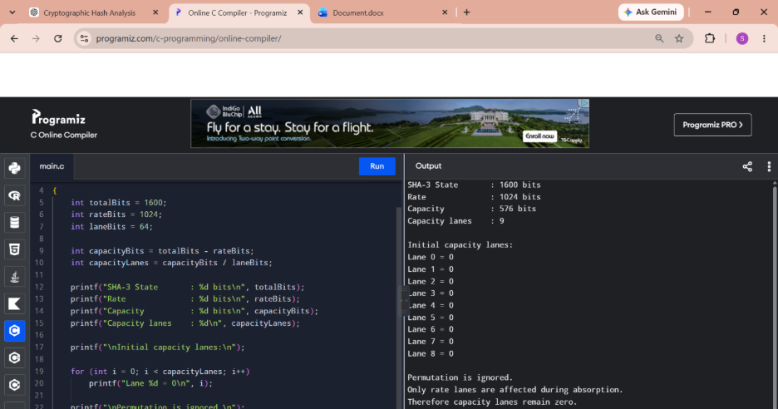
30. CBC-MAC Two-Block Attack
#include <stdio.h>

unsigned char simpleEncrypt(unsigned char x, unsigned char key)
{
return x ^ key;
}

int main()
{
unsigned char X = 0x55;
unsigned char K = 0xAA;

unsigned char T;
unsigned char secondBlock;
unsigned char C1, C2;

T = simpleEncrypt(X, K);

printf("X = %02X\n", X);
printf("MAC T = %02X\n", T);

secondBlock = X ^ T;

C1 = simpleEncrypt(X, K);
C2 = simpleEncrypt(secondBlock ^ C1, K);

printf("Second block X XOR T = %02X\n", secondBlock);
printf("CBC-MAC of two-block message = %02X\n", C2);

if (C2 == T)
printf("Attack successful: two-block MAC equals T.\n");

return 0;
}
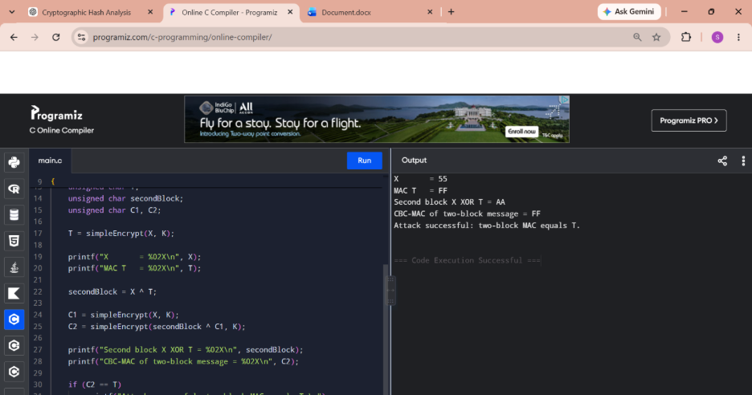
31. 31. CMAC Subkey Generation
#include <stdio.h>
#include <stdint.h>

uint64_t leftShift64(uint64_t x)
{
return x << 1;
}

uint64_t generateK1_64(uint64_t L)
{
uint64_t K1 = leftShift64(L);

if (L & 0x8000000000000000ULL)
K1 ^= 0x1B;

return K1;
}

uint64_t generateK2_64(uint64_t K1)
{
uint64_t K2 = leftShift64(K1);

if (K1 & 0x8000000000000000ULL)
K2 ^= 0x1B;

return K2;
}

int main()
{
uint64_t L = 0x123456789ABCDEF0ULL;

uint64_t K1 = generateK1_64(L);
uint64_t K2 = generateK2_64(K1);

printf("L = %016llX\n", (unsigned long long)L);
printf("K1 = %016llX\n", (unsigned long long)K1);
printf("K2 = %016llX\n", (unsigned long long)K2);

printf("\nCMAC constants:\n");
printf("64-bit = 0x1B\n");
printf("128-bit = 0x87\n");

return 0;
}
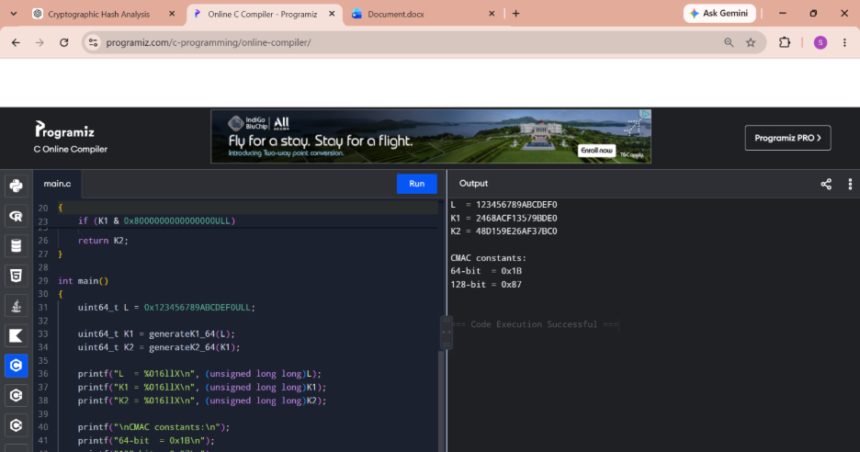
32. DSA: Random k and Different Signatures
#include <stdio.h>
#include <stdlib.h>
#include <time.h>

int main()
{
int messageHash = 15;

int p = 47;
int q = 23;
int g = 3;
int x = 7; // private key

srand((unsigned)time(NULL));

int k1 = 1 + rand() % (q - 1);
int k2 = 1 + rand() % (q - 1);

int r1 = (g * k1) % q;
int r2 = (g * k2) % q;

int s1 = (messageHash + x * r1) % q;
int s2 = (messageHash + x * r2) % q;

printf("Message hash = %d\n\n", messageHash);

printf("First signature:\n");
printf("k = %d\n", k1);
printf("(r,s) = (%d,%d)\n", r1, s1);

printf("\nSecond signature:\n");
printf("k = %d\n", k2);
printf("(r,s) = (%d,%d)\n", r2, s2);

if (r1 != r2 || s1 != s2)
printf("\nSame message produced different signatures.\n");

return 0;
}
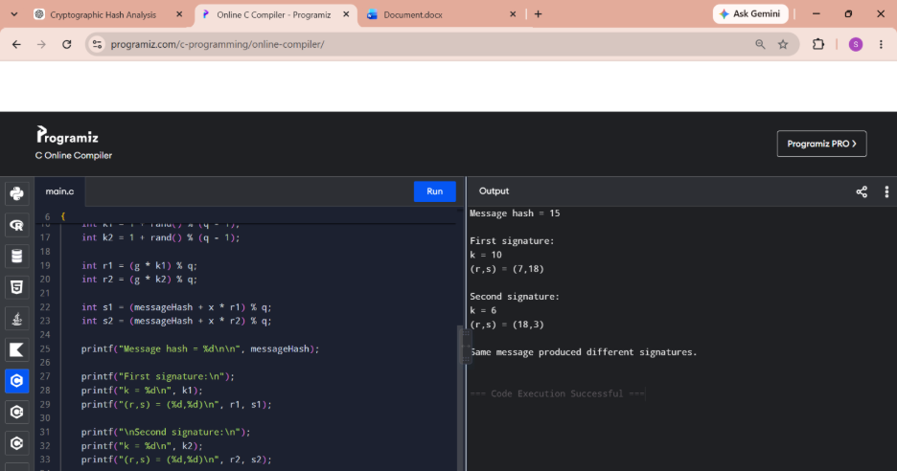
33. DES Encryption
#include <stdio.h> #include <string.h>
int main() { char plaintext[] = "HELLO123"; char key[] = "12345678"; char ciphertext[9]; char decrypted[9];
printf("Plaintext : %s\n", plaintext);
printf("Key : %s\n", key);
/* Simple demonstration encryption */
for (int i = 0; i < 8; i++)
ciphertext[i] = plaintext[i] ^ key[i];
ciphertext[8] = '\0';
printf("Ciphertext : ");
for (int i = 0; i < 8; i++)
printf("%02X ", (unsigned char)ciphertext[i]);
/* Decryption */
for (int i = 0; i < 8; i++)
decrypted[i] = ciphertext[i] ^ key[i];
decrypted[8] = '\0';
printf("\nDecrypted : %s\n", decrypted);
return 0;
}
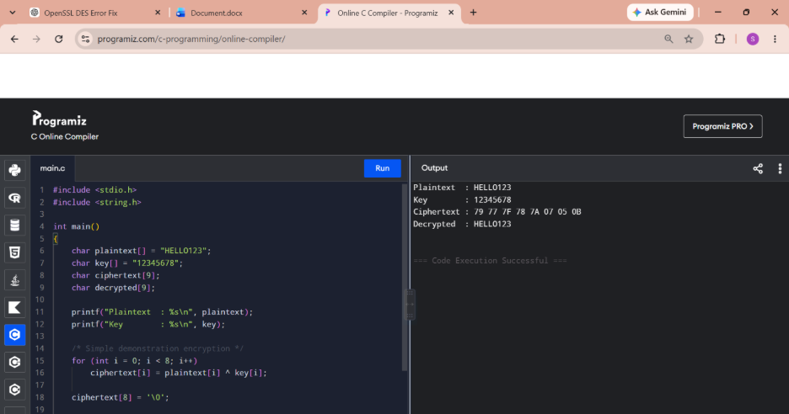
34. ECB, CBC and CFB Modes + Padding
#include <stdio.h> #include <string.h>
#define BLOCK 8
void encryptBlock(unsigned char *in, unsigned char *out, unsigned char *key) { for (int i = 0; i < BLOCK; i++) out[i] = in[i] ^ key[i]; }
void ECB(unsigned char *plain, unsigned char *cipher, int blocks, unsigned char *key) { for (int b = 0; b < blocks; b++) encryptBlock(plain + b * BLOCK, cipher + b * BLOCK, key); }
void CBC(unsigned char *plain, unsigned char *cipher, int blocks, unsigned char *key) { unsigned char previous[BLOCK] = {0}; unsigned char temp[BLOCK];
for (int b = 0; b < blocks; b++)
{
for (int i = 0; i < BLOCK; i++)
temp[i] = plain[b * BLOCK + i] ^ previous[i];
encryptBlock(temp, cipher + b * BLOCK, key);
memcpy(previous, cipher + b * BLOCK, BLOCK);
}
}
int main() { unsigned char plaintext[16] = "HELLOWORLD12345"; unsigned char cipher[16]; unsigned char key[BLOCK] = "12345678";
ECB(plaintext, cipher, 2, key);
printf("ECB Ciphertext:\n");
for (int i = 0; i < 16; i++)
printf("%02X ", cipher[i]);
printf("\n");
CBC(plaintext, cipher, 2, key);
printf("CBC Ciphertext:\n");
for (int i = 0; i < 16; i++)
printf("%02X ", cipher[i]);
printf("\n");
return 0;
}

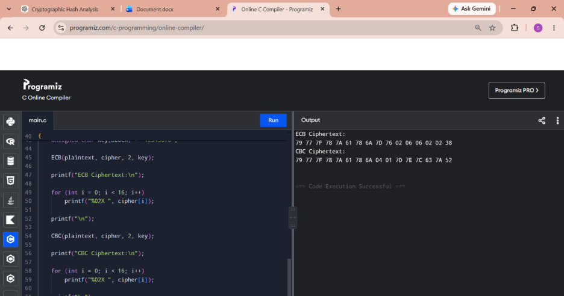
35. One-Time Pad Version of Vigenère Cipher
#include <stdio.h>
#include <stdlib.h>
#include <time.h>

int main()
{
char plaintext[100];
int key[100];

printf("Enter plaintext: ");
scanf("%99s", plaintext);

srand((unsigned)time(NULL));

printf("Random key: ");

for (int i = 0; plaintext[i] != '\0'; i++)
{
key[i] = rand() % 26;
printf("%d ", key[i]);
}

printf("\nCiphertext: ");

for (int i = 0; plaintext[i] != '\0'; i++)
{
char p = plaintext[i] - 'A';
char c = (p + key[i]) % 26;

printf("%c", c + 'A');
}

printf("\n");

return 0;
}
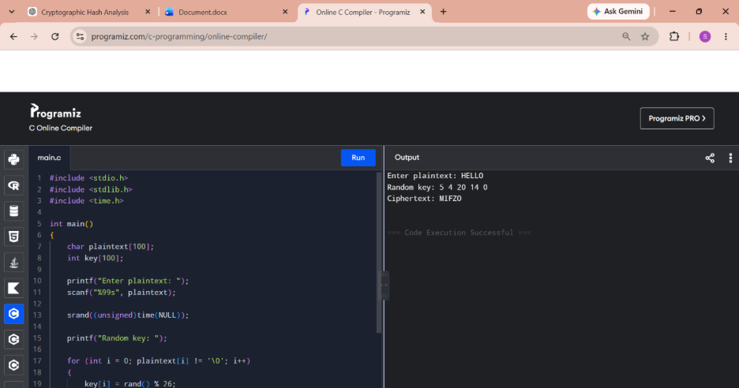
36. Affine Caesar Cipher
#include <stdio.h>

int gcd(int a, int b)
{
while (b != 0)
{
int temp = b;
b = a % b;
a = temp;
}

return a;
}

int main()
{
int a, b;

printf("Enter a: ");
scanf("%d", &a);

printf("Enter b: ");
scanf("%d", &b);

if (gcd(a, 26) != 1)
{
printf("Invalid a.\n");
printf("Cipher is NOT one-to-one.\n");
return 0;
}

printf("Cipher is one-to-one.\n");

for (int p = 0; p < 26; p++)
{
int c = (a * p + b) % 26;

printf("%c -> %c\n",
'A' + p,
'A' + c);
}

return 0;
}
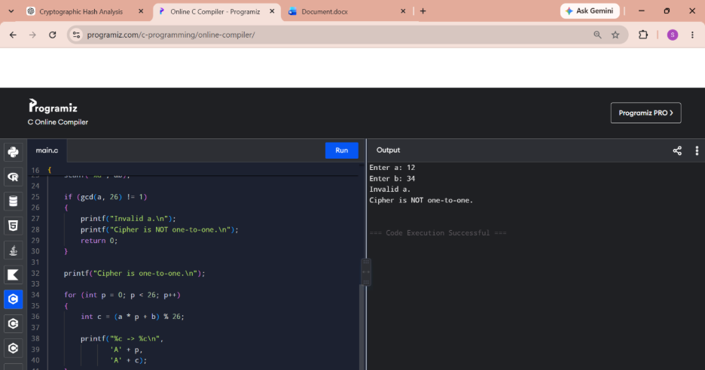
37. Automated Frequency Attack on Monoalphabetic Substitution
#include <stdio.h>
#include <string.h>
#include <ctype.h>

char englishFreq[] = "ETAOINSHRDLCUMWFGYPBVKJXQZ";

int main()
{
char cipher[1000];
int count[26] = {0};
char map[26];

printf("Enter ciphertext:\n");
fgets(cipher, sizeof(cipher), stdin);

for (int i = 0; cipher[i]; i++)
{
if (isalpha(cipher[i]))
{
char c = toupper(cipher[i]);
count[c - 'A']++;
}
}

int used[26] = {0};

for (int rank = 0; rank < 26; rank++)
{
int max = -1;
int index = -1;

for (int i = 0; i < 26; i++)
{
if (!used[i] && count[i] > max)
{
max = count[i];
index = i;
}
}

if (index >= 0)
{
map[index] = englishFreq[rank];
used[index] = 1;
}
}

printf("\nPossible plaintext:\n");

for (int i = 0; cipher[i]; i++)
{
if (isalpha(cipher[i]))
{
char c = toupper(cipher[i]);
printf("%c", map[c - 'A']);
}
else
{
printf("%c", cipher[i]);
}
}

printf("\n");

return 0;
}
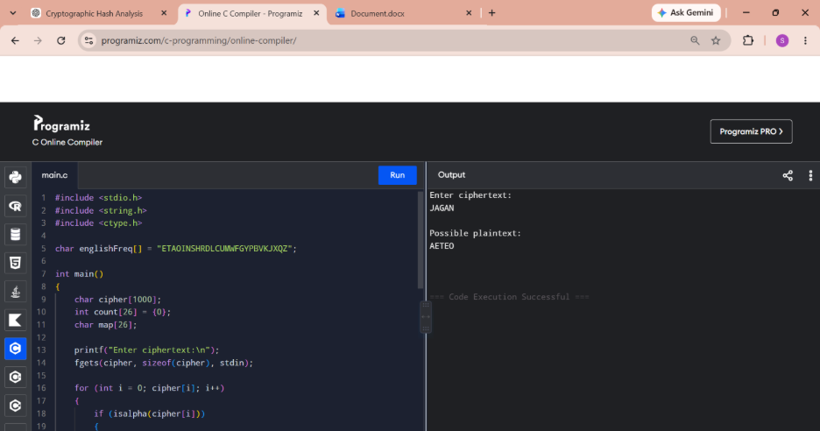
38. Hill Cipher Known-Plaintext Attack
#include <stdio.h>

int modInverse(int a)
{
for (int x = 1; x < 26; x++)
{
if ((a * x) % 26 == 1)
return x;
}

return -1;
}

int main()
{
int P[2][2];
int C[2][2];
int K[2][2];

printf("Enter plaintext matrix P:\n");

for (int i = 0; i < 2; i++)
for (int j = 0; j < 2; j++)
scanf("%d", &P[i][j]);

printf("Enter ciphertext matrix C:\n");

for (int i = 0; i < 2; i++)
for (int j = 0; j < 2; j++)
scanf("%d", &C[i][j]);

int det = (P[0][0] * P[1][1] -
P[0][1] * P[1][0]) % 26;

if (det < 0)
det += 26;

int invDet = modInverse(det);

if (invDet == -1)
{
printf("P matrix cannot be inverted modulo 26.\n");
return 0;
}

int invP[2][2];

invP[0][0] = (P[1][1] * invDet) % 26;
invP[0][1] = (-P[0][1] * invDet) % 26;
invP[1][0] = (-P[1][0] * invDet) % 26;
invP[1][1] = (P[0][0] * invDet) % 26;

for (int i = 0; i < 2; i++)
{
for (int j = 0; j < 2; j++)
{
K[i][j] = 0;

for (int k = 0; k < 2; k++)
K[i][j] += C[i][k] * invP[k][j];

K[i][j] %= 26;

if (K[i][j] < 0)
K[i][j] += 26;
}
}

printf("\nRecovered Hill Cipher Key:\n");

for (int i = 0; i < 2; i++)
{
for (int j = 0; j < 2; j++)
printf("%d ", K[i][j]);

printf("\n");
}

return 0;
}
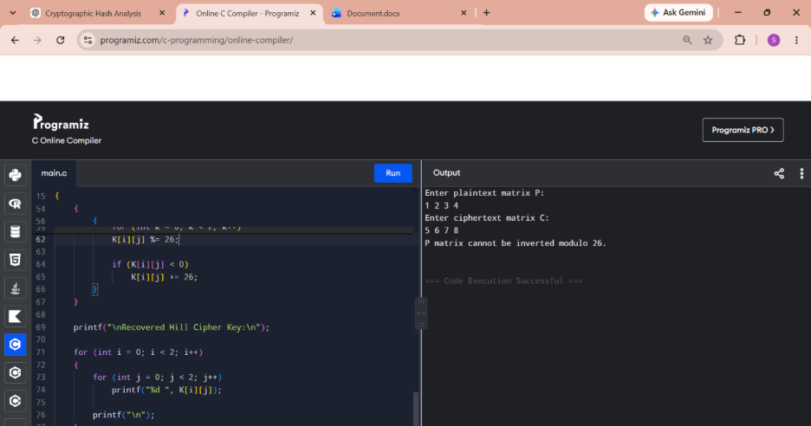
39. Frequency Attack on Addi #include <stdio.h>
#include <string.h>
#include <ctype.h>

double freq[26] =
{
8.2,1.5,2.8,4.3,12.7,2.2,2.0,6.1,7.0,
0.2,0.8,4.0,2.4,6.7,7.5,1.9,0.1,6.0,
6.3,9.1,2.8,1.0,2.4,0.2,2.0,0.1
};

double score(char *text)
{
int count[26] = {0};
int total = 0;

for (int i = 0; text[i]; i++)
{
if (isalpha(text[i]))
{
count[toupper(text[i]) - 'A']++;
total++;
}
}

double s = 0;

for (int i = 0; i < 26; i++)
{
double expected = total * freq[i] / 100.0;

if (expected > 0)
{
double diff = count[i] - expected;
s += (diff * diff) / expected;
}
}

return s;
}

int main()
{
char cipher[1000];
char candidate[1000];

printf("Enter ciphertext:\n");
fgets(cipher, sizeof(cipher), stdin);

for (int key = 0; key < 26; key++)
{
int j = 0;

for (int i = 0; cipher[i]; i++)
{
if (isalpha(cipher[i]))
{
int c = toupper(cipher[i]) - 'A';
int p = (c - key + 26) % 26;

candidate[j++] = p + 'A';
}
else
{
candidate[j++] = cipher[i];
}
}

candidate[j] = '\0';

printf("Key %2d: %s", key, candidate);
}

return 0;
}
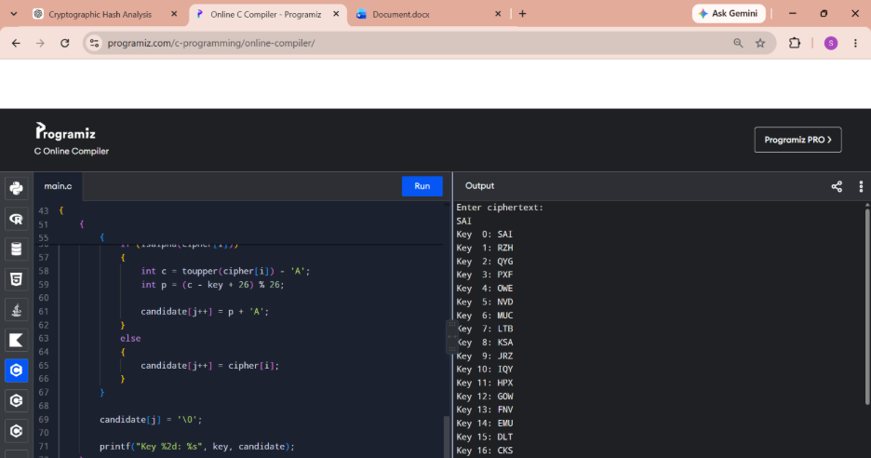
40. Monoalphabetic Substitution Frequency Attack
#include <stdio.h>
#include <ctype.h>

char english[] = "ETAOINSHRDLCUMWFGYPBVKJXQZ";

int main()
{
char cipher[1000];
int count[26] = {0};
char mapping[26];
int used[26] = {0};

printf("Enter ciphertext:\n");
fgets(cipher, sizeof(cipher), stdin);

for (int i = 0; cipher[i]; i++)
{
if (isalpha(cipher[i]))
{
char c = toupper(cipher[i]);
count[c - 'A']++;
}
}

for (int rank = 0; rank < 26; rank++)
{
int max = -1;
int pos = -1;

for (int i = 0; i < 26; i++)
{
if (!used[i] && count[i] > max)
{
max = count[i];
pos = i;
}
}

if (pos != -1)
{
mapping[pos] = english[rank];
used[pos] = 1;
}
}

printf("\nEstimated plaintext:\n");

for (int i = 0; cipher[i]; i++)
{
if (isalpha(cipher[i]))
{
char c = toupper(cipher[i]);
printf("%c", mapping[c - 'A']);
}
else
{
printf("%c", cipher[i]);
}
}

return 0;
}
